Good afternoon Big Rock families/whānau.
Can you believe we are halfway through another term!
We have had a busy week in the classrooms with lots of learning to share with our families.
Assembly
What an amazing turnout we had this week to celebrate the wonderful work of the children at Big Rock. It is always special to see their excited faces when they get to share. I was very impressed with how well they spoke to the crowd about their research projects.
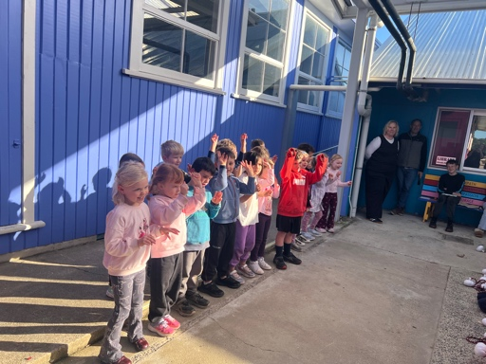 | 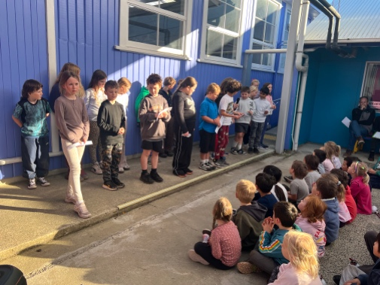 | 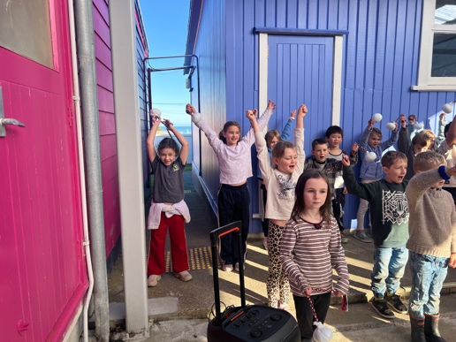
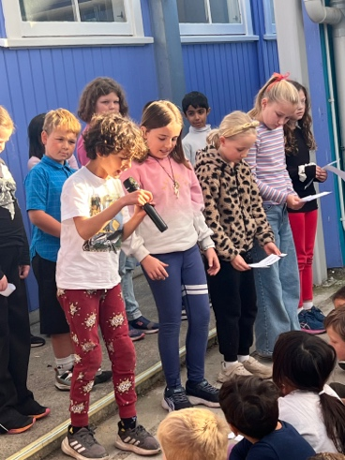 | 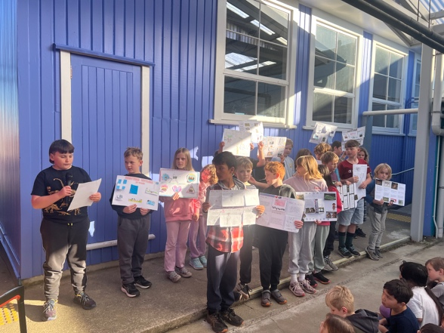

Thank You
A big thank you to Mark Henderson who was able to come and adjust the height of the new desks in Room 3. The children are no longer having to ‘write in the sky.’

Children Arriving Late to School
If you are dropping your children to school and classes have already started, we need you to get your child to sign in at the office.
If a child is not here when the roll is taken and we have not had an absentee form, the teacher marks the child as ‘unknown.’
Kelly then has to ring the parent to find out why they are not at school so it can be marked on the Ministry attendance register.
Yesterday a child did not sign in when they arrived late. Instead they went straight to another class for their lesson. Not letting the office or their classroom teacher know they had arrived.
When Kelly checked with the classroom teacher to see if the child had arrived, she was told that they had not seen them. Kelly rang the parent to ask about the absence and of course the parent’s response was ‘but I dropped them at school!’
This situation caused a lot of unnecessary anxiety for the parent, classroom teacher and Kelly.

Welcome to Big Rock
River Whatuira-Brears | Hehale Ratten
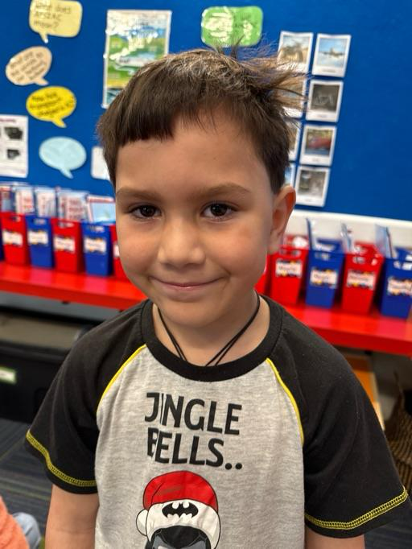 | 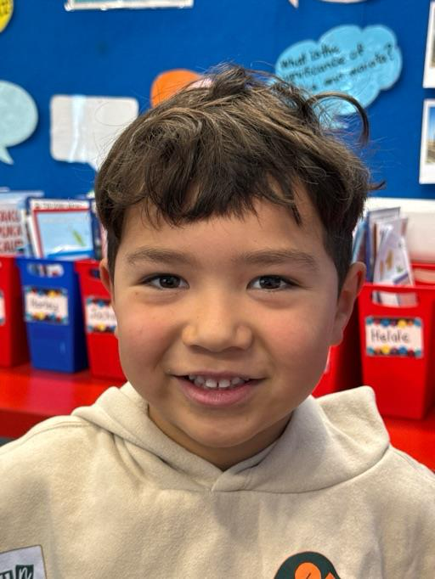
Minecraft Education
One of the many special educational opportunities available at Big Rock is our Minecraft Education Programme lead by Kara. Over the next few weeks Kara and Room 5 will be collaborating with other classes to design their own Minecraft world. This week Room 1 were lucky enough to create their own Phonics Island.
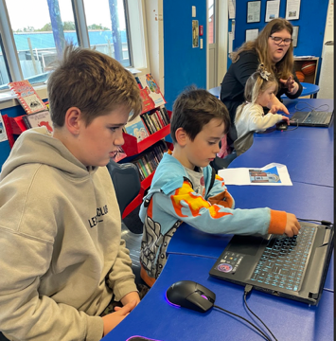 | 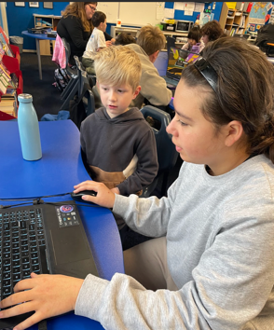 | 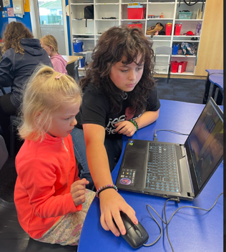 | 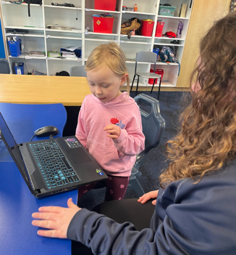
School Sores/Impetigo
We are still seeing new cases of this each week throughout the school. Please be aware that the bacteria can survive on surfaces for up to 2 weeks and is highly contagious.
We need you to be vigilant about taking children to the doctor with any unusual spots or crusty, cold sore like lesions.

Listenting Laughing Learning Looking After Others
Some Big Rock students who were ‘caught’ displaying our school values this week were –
Kolton Haggerty Walker – Learning – excellent work during phonics lessons.
Quaye Driver – Learning – fantastic effort on his research project.

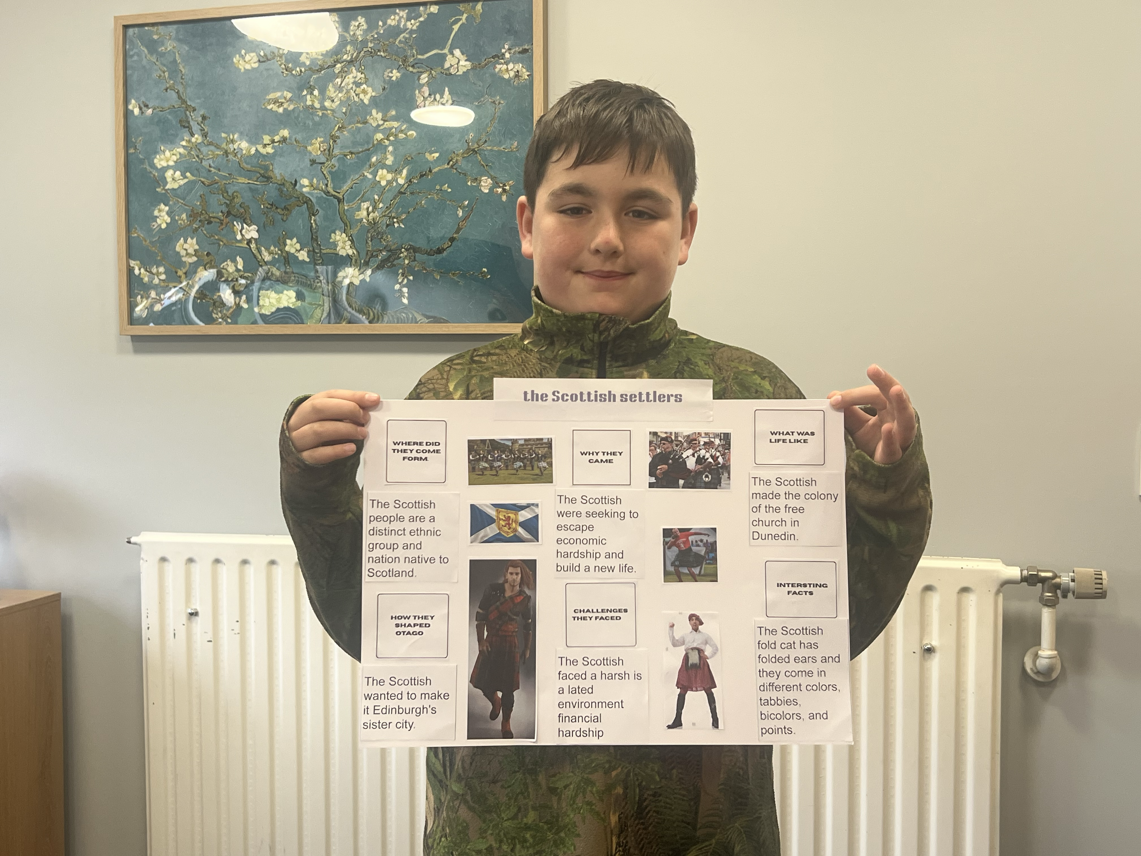

Sports Roundup

Player of the Day for the Big Rock Hoopsters was Leon Skerratt. | 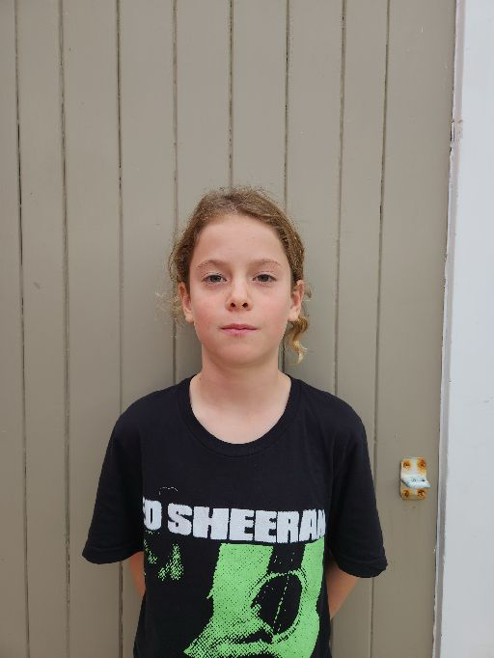 | Ari Gilbert received Player of the Day for ‘outstanding passing and goal scoring’. | 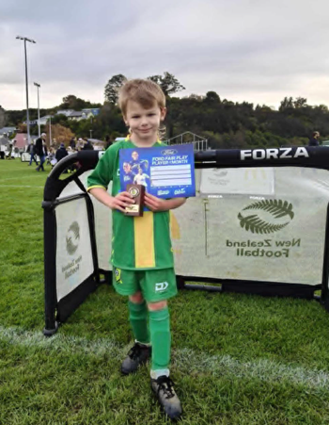

Smoke-Free and Vape-Free School Environment
At Big Rock Primary, we are committed to maintaining a safe and healthy environment for all students.
As outlined in our school policy: “Parents and caregivers who choose to smoke or vape must not do so around children or within sight of children.”
We kindly ask all members of our school community to support this expectation. If staff observe smoking or vaping near the gates or around students, you may be asked to stop or move further away from the area.
Thank you for helping us provide a positive and healthy environment for our tamariki.
Upcoming Events
King’s Birthday – 1st June – School closed.
Board of Trustees Meeting – 9th June – 3.30pm in the staffroom.
Aotearoa New Zealand Histories Trips – Rooms 3, 4 and 5 – 11th June
- Rooms 1 and 2 – 23rd June
Year 6, 7 and 8 Bike Trip – Date to be advised.
Matariki Celebration – 1st July – Brighton Hall.
End of Term – 3rd July.

Keith from Project Excavation Landscape is responsible for our school looking so smart. If you have any landscaping or excavation projects we highly recommend using his services.




Reminders
School Accounts
With school camps coming up later in the year, families often opt to start a direct credit now to pre pay for this. If you wish to start a direct credit for camp or to pay your school account, the school bank account details are – Big Rock School – 02 0900 0000225 00
Please let Kelly know if you do start a direct credit payment.
Pool Keys
We have had almost all of the pool keys returned!
Where applicable the deposit has been credited to your school account.

Knowing if your child is well enough to go to school — guidance for parents and caregivers.
If you are not sure if your child is well enough to go to school, the Ministry of Health have a quick guide where you can check your child’s symptoms to make an informed decision.
Google – knowing if your child is well enough to go to school.

After School Care
Bookings or cancellations for After School Care can be made by texting 021 082 50863 or by emailing asc@bigrock.school.nz.

Office Hours
Monday and Wednesday – 8.45am – 3.15pm
Tuesday, Thursday and Friday – 8.45am – 12.15pm
Kelly is only in the office between these hours.
Please note that if your call goes to the answer phone, leave us a message. Staff may not be able to answer the phone at that time but will check the machine as soon as they can.

Sushi
Sushi is available for lunch every second Wednesday. You can order this by using the Kindo/Ezlunch app.
The dates for sushi lunches for the rest of the term are:
Wednesday: 3rd June, 17th June and 1st July

Lunch Orders
These can be made at the shop on a Friday or dropped at the school office before 9.00am.

Lost Property
This can be located in the library.

Absences
Thank you for getting your absences and late notifications in before 8.50am on Skool Loop.
It saves us a lot of time if we don’t have to chase these up.

The new Stepped Attendence Responce Regulations from the Ministry of Education and what they mean.
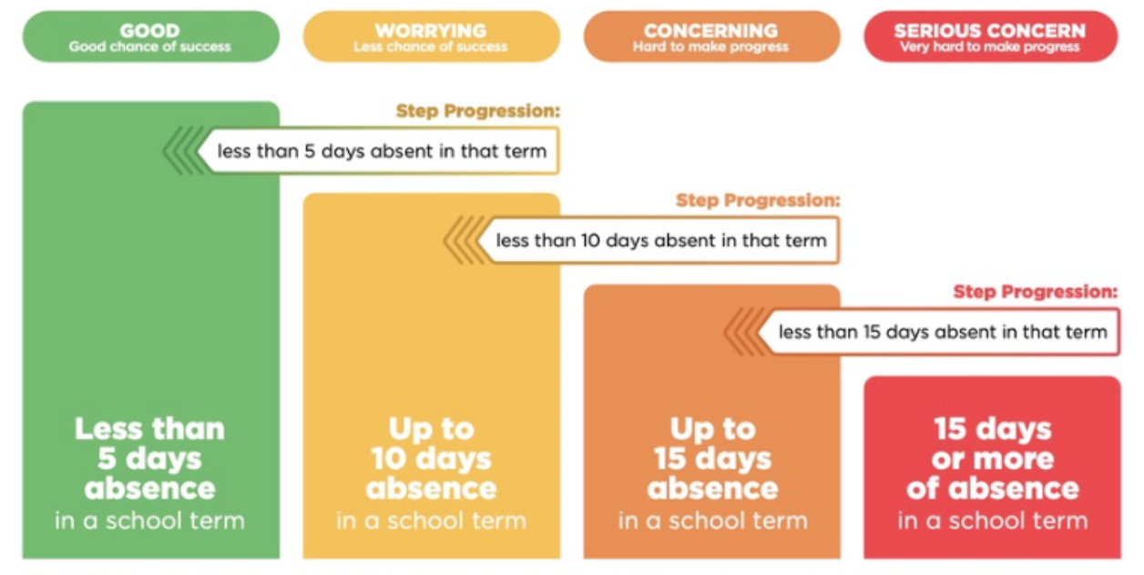
An automatic email will be sent from EDGE, as per Ministry requirements, when absences reach 4.5 half days in a term.

Lisa Lamb
actingprincipal@bigrock.school.nz
Message 020 432 6657 available between 7.30am and 4.30pm Monday to Friday.

