Good afternoon Big Rock families/whānau.
I hope you are keeping warm in this stormy weather. Please remember to get your predictions for the World Cup competition in.
School Accounts
With the end of term approaching it would be appreciated if any outstanding school accounts could be paid in full or a direct credit set up to clear these please.
If you wish to start a direct credit to pay your school account, the school bank account details are – Big Rock School – 02 0900 0000225 00
Please let Kelly know if you do start a direct credit payment.
Matariki
Our annual Matariki celebration is happening next Wednesday, the 1st July at the Brighton Hall.
This is a big event on the Big Rock Calendar and a chance for all of our families to come together to enjoy not only some delicious kai but also each others company. The school will be providing a lamb on the spit, lasagne, sausages, as well as some other carefully prepared dishes.
We ask each family to bring a dish that is special to your family to share with others and also your own cutlery and plates.
Doors will open at 5.45pm. We look forward to seeing you all there.
What’s Been Happening Around the School?
Room One and Two visited Toitu Museum on Tuesday this week to learn more about the early settlers to New Zealand and transport. Danny taught us how all the parts of the old Steam Engines work and we acted it out as coal, fire, pistons and wheels. We also galloped around each town on a trip to the goldfields. A really fun day of learning, thanks to all our parent helpers.
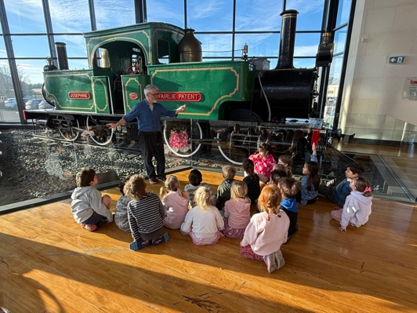 | 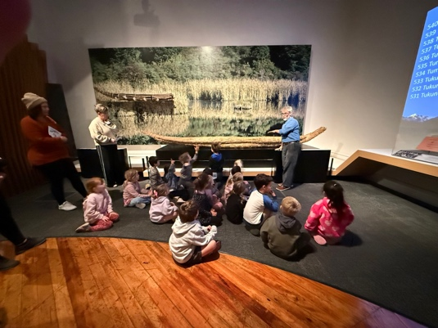 | 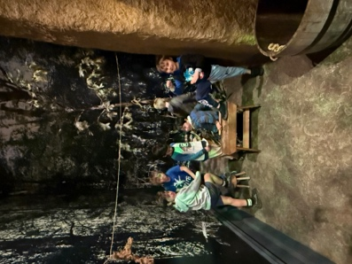

Welcome to Big Rock!
Vera Knierum | Johnny Bright | Billy Bright
 | 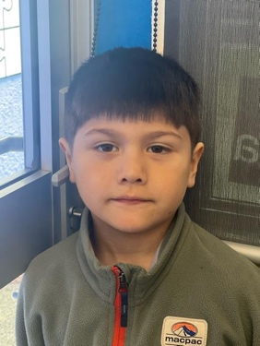 | 
Late Students
We have seen a marked improvement over the last week with children arriving before 8.50am.
Thank you for your support in helping students arrive at school on time and ready for learning.
Please note that our Student Management System, EDGE, now automatically sends notifications to parents and caregivers when a student is marked late, in line with Ministry of Education requirements.
Minecraft Education
Last week Room Two students were investigating Māori culture and native New Zealand animals through a scavenger hunt. Today some Room Three students got stranded on a deserted island and had to find resources to survive. Once again Room Five students have been outstanding during these collaborative sessions.
 | 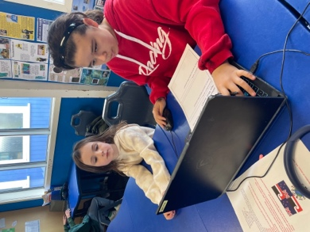 | 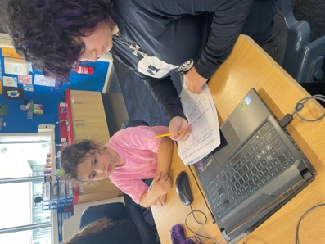 | 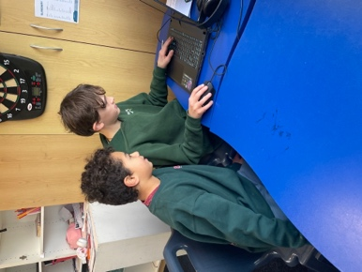
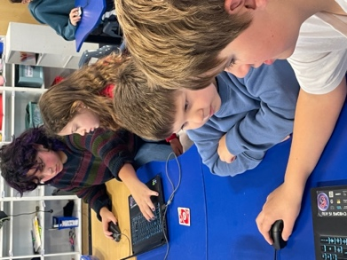 | 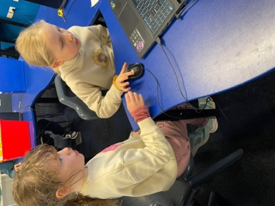 | 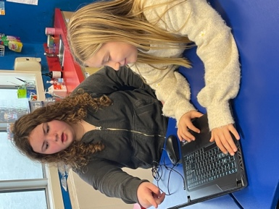

Food for Thought
“Learning begins with listening.” Native American Proverb.
Treat Food.
We kindly ask that treat foods such as chocolate, lollies, flavoured milk, and similar items are not included in school lunches.
These foods are best enjoyed at home after school. Thank you for your support.
Listening Laughing Learning Looking After Others
Some Big Rock students who were ‘caught’ displaying our school values this week were –
Grace Nicolaou – fantastic listening, learning and behaviour on the school trip.
Ada McIver – fantastic listening, learning and behaviour on the school trip.
Liliana Hebberd – helping others in the classroom and playground.
Baily Jenkinson – can always be relied upon to help out in any situation.

Sports Roundup

Jed Grey got Player of the  Day for the Green Island Yr 6 Glacier Bears. Well done! | Quaye Driver got Player of the Day for the Big Rock Hoopsters Awesome work! | Greyson Farquhar got Player of the Day for Kaikorai Yr 4. Fantastic effort!
 |  | 

Upcoming Events
Matariki Celebration – Wednesday, July 1st– Brighton Hall. Doors open at 5.45pm.
End of Term – Friday, July 3rd.
First Day of Term 3 – Monday, July 20th.
Year 6, 7 and 8 Bike Trip – Date to be advised.

Keith from Project Excavation Landscape is responsible for our school looking so smart. If you have any landscaping or excavation projects we highly recommend using his services.



Reminders
Sushi
Sushi is available for lunch every second Wednesday. You can order this by using the Kindo/Ezlunch app.
* Please note there are no orders on the 1st of July as the shop is closed.
Term 3 sushi.
Wednesday 22nd July. 5th, 19th August. 2nd, 16th September.

Knowing if your child is well enough to go to school — guidance for parents and caregivers.
If you are not sure if your child is well enough to go to school, the Ministry of Health have a quick guide where you can check your child’s symptoms to make an informed decision.
Google – knowing if your child is well enough to go to school.
After School Care
Bookings or cancellations for After School Care can be made by texting 021 082 50863 or by emailing asc@bigrock.school.nz.
Office Hours
Monday and Wednesday – 8.45am – 3.15pm
Tuesday, Thursday and Friday – 8.45am – 12.15pm
Kelly is only in the office between these hours.
Please note that if your call goes to the answer phone, leave us a message. Staff may not be able to answer the phone at that time but will check the machine as soon as they can.
Lunch Orders
These can be made at the shop on a Friday or dropped at the school office before 9.00am.

Lost Property
This can be located in the library.

Absences
Thank you for getting your absences and late notifications in before 8.50am on Skool Loop.
It saves us a lot of time if we don’t have to chase these up.

The new Stepped Attendence Responce Regulations from the Ministry of Education and what they mean.
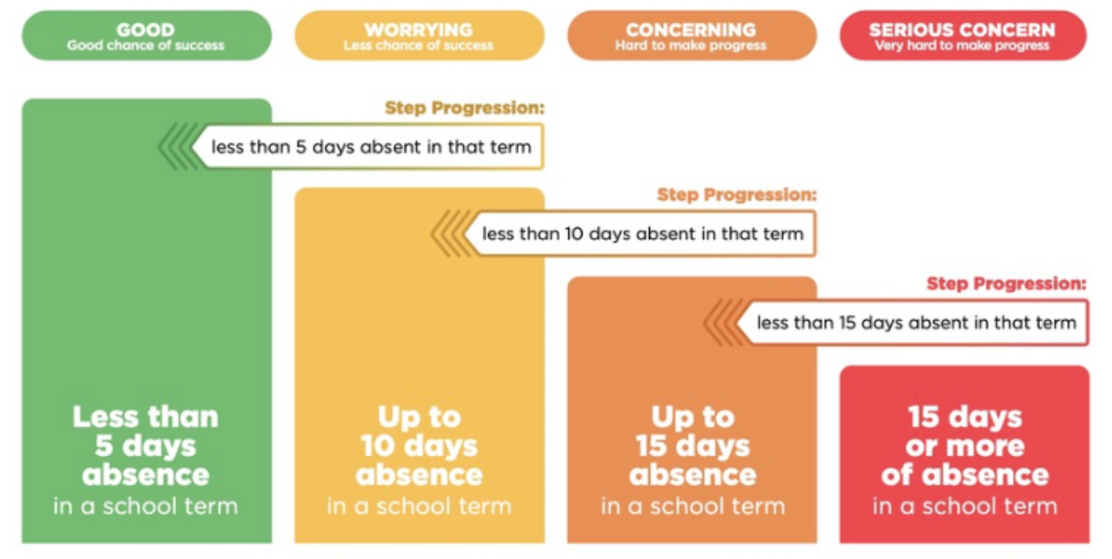
An automatic email will be sent from EDGE, as per Ministry requirements, when absences reach 4.5 half days in a term.
Any absence must be recorded in accordance with the Ministry of Education attendance guidelines.
You can find further information about this on the Big Rock Primary School website under policies.

Lisa Lamb
actingprincipal@bigrock.school.nz

