Good afternoon Big Rock families/whānau.
Welcome back to Term 2.
It has been fantastic to see all of the bright, smiling faces back at school ready for learning.
You may have noticed a change to two of the classrooms over the holidays. Due to class sizes, we made the decision to change Rooms 1 and 2 over to allow students more learning space.
Big Rock staff have been very busy with ongoing professional development around the new curriculum, SMART assessment and EDGE, our attendence and reporting system. As well as working hard preparing lessons, teaching, assessment, general school admin and preparing for report writing. It is a very busy time.
ANZAC, Aotearoa New Zealand Histories and Matariki are our topic focuses this term. The teachers are planning class trips related to this for later in the term. Dates to be advised.
As winter approaches, please ensure that children come to school dressed appropriately for the colder weather, including bringing a jacket for break times and outdoor activities. We appreciate your support and cooperation.

Pool Keys
If you still have a pool key, please return it as soon as possible. Managing outstanding keys requires significant administrative time, and we appreciate your help in reducing this.
If your key has been lost, please inform us so we can update our records accordingly.
ANZAC Day
It is a public holiday on Monday the 27th April and school will be closed.
Fundraisers
Thank you to everyone who supported the bulb and chocolate fundraisers last term.
There are still some boxes of Whittaker’s chocolate if you would like more to sell.

Sushi
Due to the increased cost of fuel, our sushi providers have had to change how often they are able to deliver sushi to Big Rock. Going forward sushi orders will be every fortnight.
We have also been told that they will need a minimum of 20 orders to make it worthwhile, so please support this if you can.

Sports News

Netball
If your child is keen to play netball, please come in and see me.
We need some Year 4, 5 or 6 players to make a team.

Sports Uniforms
Can we please have all sports tops returned asap so that we can do a stocktake. Thank you.
I also need any basketball shirts back please. Even if you are playing this year, we need them back.

Upcoming Events
ANZAC Day – 27th April – School closed.
2nd Year Teaching Students on placement – 4th May to 22nd May.
Board of Trustee Meeting – 5th May – 3.30pm in the staffroom.
Life Education – 6th May to 8th May.
Assembly – 20th May.
3rd Year Teaching Students on placement – 25ht May to 12th June.
King’s Birthday – 1st June – School closed.
Board of Trustees Meething – 9th June – 3.30pm in the staffroom.
End of Term – 3rd July.

Listenting Laughing Learning Looking After Others
Some Big Rock students who were ‘caught’ displaying our school values this week were –
Hinemoana Jimenez Maxwell – looking after others in the playground.
Adelaide Conway - looking after others in the playground.
Vienna Garth - looking after others in the playground.

Reminders
After School Care
Bookings or cancellations for After School Care can be made by texting 021 082 50863 or by emailing asc@bigrock.school.nz.

Absences
Thank you for getting your absences and late notifications in before 8.50am on Skool Loop.
It saves us a lot of time if we don’t have to chase these up.
Office Hours
Monday and Wednesday – 8.45am – 3.15pm
Tuesday, Thursday and Friday – 8.45am – 12.15pm
Kelly is only in the office between these hours.
Please note that if your call goes to the answer phone, leave us a message. Staff may not be able to answer the phone at that time but will check the machine as soon as they can.

Sushi
Sushi is available for lunch every second Wednesday. You can order this by using the Kindo/Ezlunch app.
The dates for sushi lunches for the rest of the term are:
Wednesday: 6th May, 20th May, 3rd June, 17th June and 1st July

Lunch Orders
These can be made at the shop on a Friday or dropped at the school office before 9.00am.

Lost Property
This can be located in the library.
The new Stepped Attendence Responce Regulations from the Ministry of Education and what they mean.
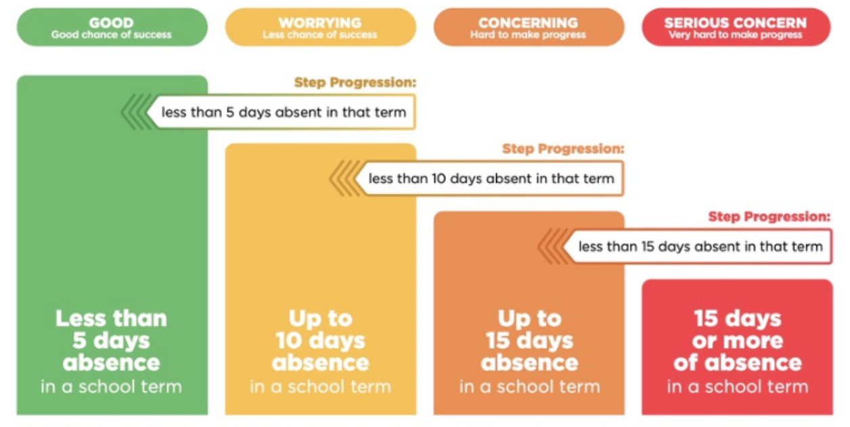
An automatic email will be sent from EDGE, as per Ministry requirements, when absences reach 4.5 half days in a term.

If you have any questions, please contact us.
Lisa Lamb
Acting Principal
actingprincipal@bigrock.school.nz
Ph 020 432 6657 available between 7.30am and 4.30pm Monday to Friday.

