Good afternoon Big Rock families/whānau.
This week we completed our yearly student survey with Big Rock students. We ask students a variety of questions about school including ‘what things would you like to see changed?’ It is always interesting to see their answers. Some of the suggestions this year were – a hydro slide into the pool, fish in the swimming pool, get a school dog and my favourite, a slide from the classroom to the playground so I don’t have to walk because my legs get tired from playing .
The Room 3, 4 and 5 students have been bringing their bikes on a Friday, practicing for their bike trip. It has been amazing to see the improvement in some of our less confident students. On Monday Mrs Grant and I were approached by one of these students who had a big grin on his face and told “I can’t wait for you to see me bike this week! I have been practicing with Dad.”
Project Landscaping Excavation
A huge thank you to Keith from Project Landscaping Excavation for providing 40 cubic metres of woodchips to our school playgrounds, making them safer for our children and looking fabulous!
Keith also brought along his digger to help spread the wood chips, lay gravel, and dig out the flax bushes — it has made a huge difference!
Please check out Keith and his team for all your landscaping and excavation work. A great local business
A big thank you as well to our amazing helpers Colin, Annette, Craig, Tania, Hamish, Sally, and Colin for all your hard work. Together the team helped spread wood chips, clear out the spouting and a general tidy up.
School Sores/Impetigo
We are still seeing new cases of this each week throughout the school. Please be aware that the bacteria can survive on surfaces for up to 2 weeks and is highly contagious.
We need you to be vigilant about taking children to the doctor with any unusual spots or crusty, cold sore like lesions.
Listenting Laughing Learning Looking After Others
Some Big Rock students who were ‘caught’ displaying our school values this week were –
Korbyn Parata-Walters – Looking After Others – helping students in the playground and classroom.
Fletcher Graham – Looking After Others – helping a distressed student after school to find their caregiver.
Willow Parker – Learning – working hard and producing amazing writing.
Alex Little – Learning – working hard on developing his cycling skills.

Sports Roundup

Player of the Day for the Big Rock Hoopsters was Lily Scott. | 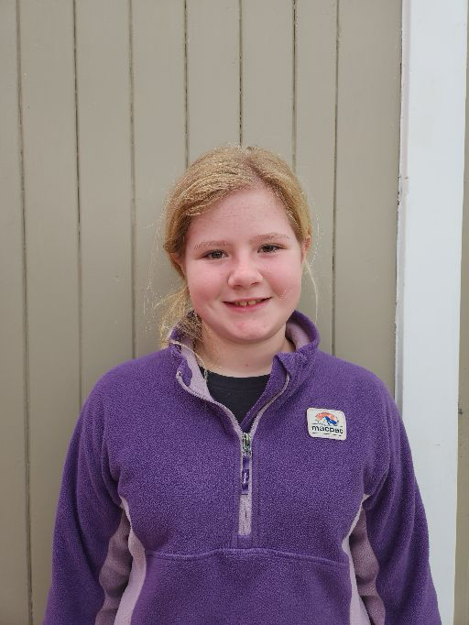 | Well done Alex Judd for earning Player of the Day for Green Island Stingrays. This is Alex’s first year playing football. | 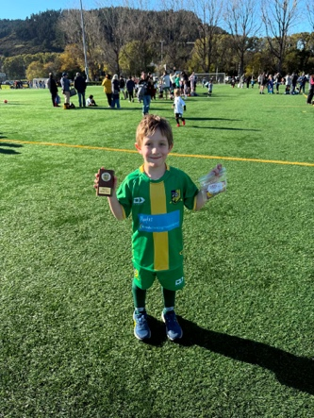

Providing a Safe Environment for Students
Recently, it was brought to our attention that a student was approached by a parent in the playground after school regarding an incident that had been shared by their child.
As a school, our priority is to provide a safe and supportive environment for all students. Any concerns or issues involving students should be addressed through the school so they can be managed appropriately and fairly.
To support this process, we ask that:
- Children report any concerns or incidents to the classroom or duty teacher as soon as possible so staff can help resolve the situation.
- If your child shares a concern with you, please encourage them to speak with their teacher, or alternatively, contact the school directly so we can support all students involved.
Parents and caregivers should not approach or reprimand students directly. If you have concerns, please contact the school and we will work with you to address the matter appropriately.
We also encourage our community to remember that there are often multiple perspectives to any situation, and children may not always share every detail when recounting events.

Submitting Absences
When submitting an absence through Skool Loop can we please ask that you provide more information than just ‘unwell’. There are a lot of different illnesses around at the moment and it helps Kelly to know exactly what the symptoms are that your child is experiencing.

Smoke-Free and Vape-Free School Environment
At Big Rock Primary, we are committed to maintaining a safe and healthy environment for all students. Over recent weeks, we have become increasingly concerned about parents and caregivers smoking or vaping while waiting at the school gates.
As outlined in our school policy:
“Parents and caregivers who choose to smoke or vape must not do so around children or within sight of children.”
We kindly ask all members of our school community to support this expectation. If staff observe smoking or vaping near the gates or around students, you may be asked to stop or move further away from the area.
Thank you for helping us provide a positive and healthy environment for our tamariki.
Communication with Teachers
While we value strong communication with our families, we kindly ask that parents and caregivers avoid contacting teachers via phone or social media outside of school hours or during weekends.
If you need to get in touch, please email your child’s teacher. Please note that responses may not be provided until the next working day.
Thank you for your understanding and cooperation.
Upcoming Events
3rd Year Teaching Students on placement – 25th May to 12th June.
Assembly – 27th May.
King’s Birthday – 1st June – School closed.
Board of Trustees Meething – 9th June – 3.30pm in the staffroom.
Aotearoa New Zealand Histories Trips – Rooms 3, 4 and 5 – 11th June
- Rooms 1 and 2 – 25th June
Year 6, 7 and 8 Bike Trip – Date to be advised.
Matariki Celebration – 1st July – Brighton Hall.
End of Term – 3rd July.

Reminders
School Accounts
With school camps coming up later in the year, families often opt to start a direct credit now to pre pay for this. If you wish to start a direct credit for camp or to pay your school account, the school bank account details are – Big Rock School – 02 0900 0000225 00
Please let Kelly know if you do start a direct credit payment.
Pool Keys
There are still a few outstanding keys.
Please return these to the office. Thank you.

Knowing if your child is well enough to go to school — guidance for parents and caregivers.
If you are not sure if your child is well enough to go to school, the Ministry of Health have a quick guide where you can check your child’s symptoms to make an informed decision.
Google – knowing if your child is well enough to go to school.

After School Care
Bookings or cancellations for After School Care can be made by texting 021 082 50863 or by emailing asc@bigrock.school.nz.

Office Hours
Monday and Wednesday – 8.45am – 3.15pm
Tuesday, Thursday and Friday – 8.45am – 12.15pm
Kelly is only in the office between these hours.
Please note that if your call goes to the answer phone, leave us a message. Staff may not be able to answer the phone at that time but will check the machine as soon as they can.

Sushi
Sushi is available for lunch every second Wednesday. You can order this by using the Kindo/Ezlunch app.
The dates for sushi lunches for the rest of the term are:
Wednesday: 3rd June, 17th June and 1st July

Lunch Orders
These can be made at the shop on a Friday or dropped at the school office before 9.00am.

Lost Property
This can be located in the library.

Absences
Thank you for getting your absences and late notifications in before 8.50am on Skool Loop.
It saves us a lot of time if we don’t have to chase these up.

The new Stepped Attendence Responce Regulations from the Ministry of Education and what they mean.
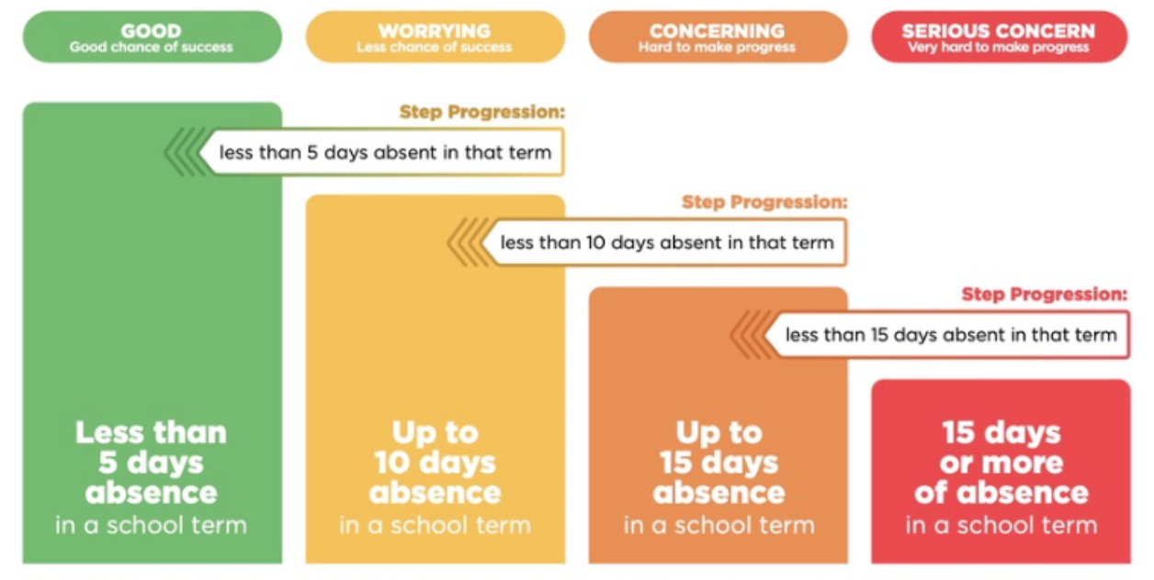
An automatic email will be sent from EDGE, as per Ministry requirements, when absences reach 4.5 half days in a term.

Lisa Lamb
actingprincipal@bigrock.school.nz
Ph 020 432 6657 available between 7.30am and 4.30pm Monday to Friday.

