Good afternoon Big Rock families/whānau.
Not long to go until the end of the term. The teachers are just finishing up their assessments and started their report writing. We will be having parent teacher interviews at the start of next term for those that wish to discuss reports.
Matariki
Our annual Matariki celebration is happening on Wednesday the 1st July at the Brighton Hall.
This is a big event on the Big Rock Calendar and a chance for all of our families to come together to enjoy not only some delicious kai but also each others company.
We ask each family to bring a dish that is special to your family to share with others and also your own cutlery and plates.
The school will be providing a lamb on the spit, lasagne, sausages, as well as some other carefully prepared dishes.
Doors will open at 5.45pm. We look forward to seeing you all there.
What’s Been Happening Around the School?
Constable Ross Greer visited the Yr 5, 6,7 and 8 students to talk about cyber safety and cyber bullying.
He discussed what these terms mean, how we can keep ourselves safe online and what to do if you experience cyber bullying.
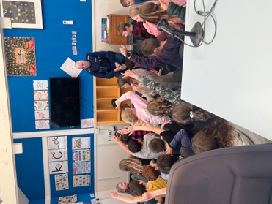 | 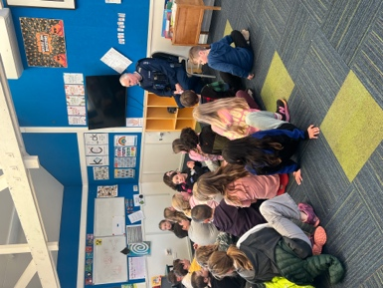
Late Students
We are noticing an increasing number of students arriving at school after 9.00am. To ensure accurate attendance records, any student arriving after 9.00am must report to the office to sign in and will be recorded as late. Please note that our Student Management System, EDGE, now automatically sends notifications to parents and caregivers when a student is marked late, in line with Ministry of Education requirements.
Thank you for your support in helping students arrive at school on time and ready for learning.

Minecraft Education
This week the Room 3 students got to be stranded on a deserted island and they had to find resources to survive. Thank you Room 5 students who have been outstanding during all of these collaborative sessions.
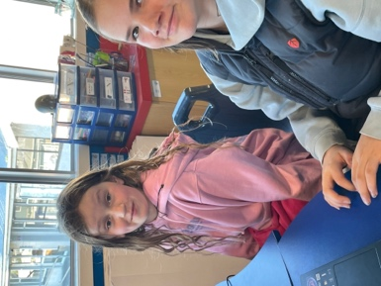 | 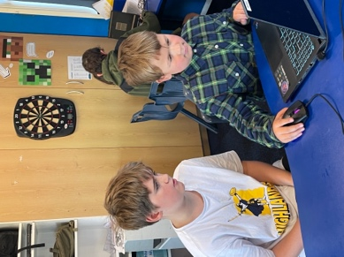 | 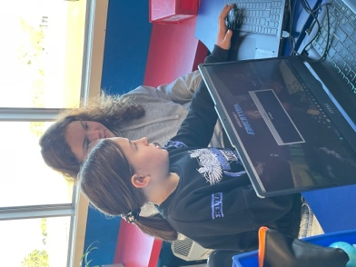
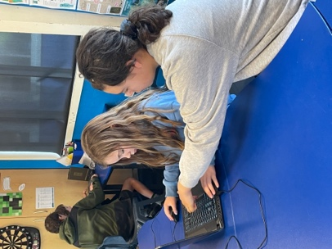 | 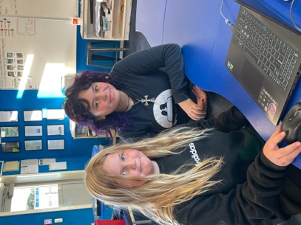

Food for Thought
“The more that you read, the more things you will know, the more that you learn, the more places you’ll go.” Dr Seuss

Listening Laughing Learning Looking After Others
Some Big Rock students who were ‘caught’ displaying our school values this week were –
Billie McNab – Looking after others.
Pearl Mansfield – Looking after others.
Charlie Rackham – Looking after others.
Baily Jenkinson – Looking after others.
Hehale Ratten – Being thoughtful with his words and actions.
Loyalty Patterson – Working hard on his learning in class.
Atiana Reihana – Great work during Maths.
Alime Tutgun – Great work during Maths.
Cecil Williams – Working hard on his learning in class.

Sports Roundup

Kendrick Keki got Player of the  Day for the Green Island Sharks. Fantastic effort! | Fletcher Cockburn got Player of the Day for the Southern Magpies and scored his first try. Well done! | Willow Parker got Player of the Day for Taieri Y2 Gold. Awesome work!
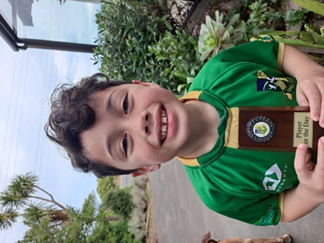 | 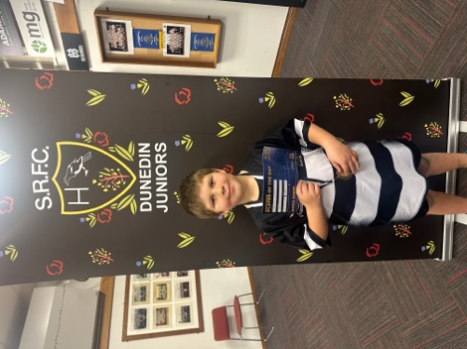 | 

Upcoming Events
Aotearoa New Zealand Histories Trip - Rooms 1 and 2 – Tuesday, June 23rd.
Matariki Celebration – Wednesday, July 1st– Brighton Hall. Doors open at 5.45pm.
End of Term – Friday, July 3rd.
First Day of Term 3 – Monday, July 20th.
Year 6, 7 and 8 Bike Trip – Date to be advised.

Keith from Project Excavation Landscape is responsible for our school looking so smart. If you have any landscaping or excavation projects we highly recommend using his services.



Reminders
Sushi
Sushi is available for lunch every second Wednesday. You can order this by using the Kindo/Ezlunch app.
* Please note there are no orders on the 1st of July as the shop is closed.
Term 3 sushi.
Wednesday 22nd July. 5th, 19th August. 2nd, 16th September.
School Accounts
Please ensure that your school accounts are up to date. Thank you.
With school camps coming up later in the year, families often opt to start a direct credit now to pre pay for this. If you wish to start a direct credit for camp or to pay your school account, the school bank account details are – Big Rock School – 02 0900 0000225 00
Please let Kelly know if you do start a direct credit payment.
Knowing if your child is well enough to go to school — guidance for parents and caregivers.
If you are not sure if your child is well enough to go to school, the Ministry of Health have a quick guide where you can check your child’s symptoms to make an informed decision.
Google – knowing if your child is well enough to go to school.
After School Care
Bookings or cancellations for After School Care can be made by texting 021 082 50863 or by emailing asc@bigrock.school.nz.
Office Hours
Monday and Wednesday – 8.45am – 3.15pm
Tuesday, Thursday and Friday – 8.45am – 12.15pm
Kelly is only in the office between these hours.
Please note that if your call goes to the answer phone, leave us a message. Staff may not be able to answer the phone at that time but will check the machine as soon as they can.
Lunch Orders
These can be made at the shop on a Friday or dropped at the school office before 9.00am.

Lost Property
This can be located in the library.

Absences
Thank you for getting your absences and late notifications in before 8.50am on Skool Loop.
It saves us a lot of time if we don’t have to chase these up.

The new Stepped Attendence Responce Regulations from the Ministry of Education and what they mean.
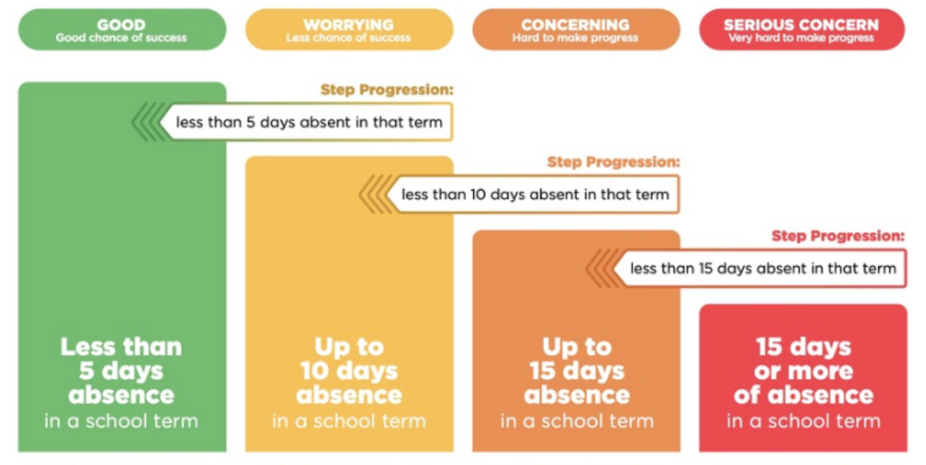
An automatic email will be sent from EDGE, as per Ministry requirements, when absences reach 4.5 half days in a term.
Any absence must be recorded in accordance with the Ministry of Education attendance guidelines.
You can find further information about this on the Big Rock Primary School website under policies.

Lisa Lamb
actingprincipal@bigrock.school.nz

