Good afternoon Big Rock families/whānau.
Hopefully you have read the Skool Loop and Facebook notifications regarding Impetigo.
This is a highly contagious condition that needs to be treated as soon as possible. We need your help to stop the spread.
Please be vigilant with personal hygiene, get any spots checked by a doctor as soon as possible and keep your children home until they have been on treatment for 24 hrs.
We appreciate your support.
Support Staff Week
I would like to acknowledge wonderful support staff that we have at Big Rock. We couldn’t do half of what we do without your hard work and support. Thank you!
Kelly Adie, Kara Walters, Kerry Turner and Georgia Smith.
School Accounts
With school camps coming up later in the year, families often opt to start a direct credit now to pre pay for this. If you wish to start a direct credit for camp or to pay your school account, the school bank account details are – Big Rock School – 02 0900 0000225 00
Please let Kelly know if you do start a direct credit payment.
Pool Keys
There are still a few outstanding keys.
Please return these to the office. Thak you.

Welcome to Big Rock

A big welcome to Maple Wilson who started in Room1 this week. | 

Sports Roundup

Player of the Day for the Big Rock Hoopsters was Jaxon Skerratt. |  | Well done Maci Kippenberger for earning Player of the Day for Taieri Rugby. | 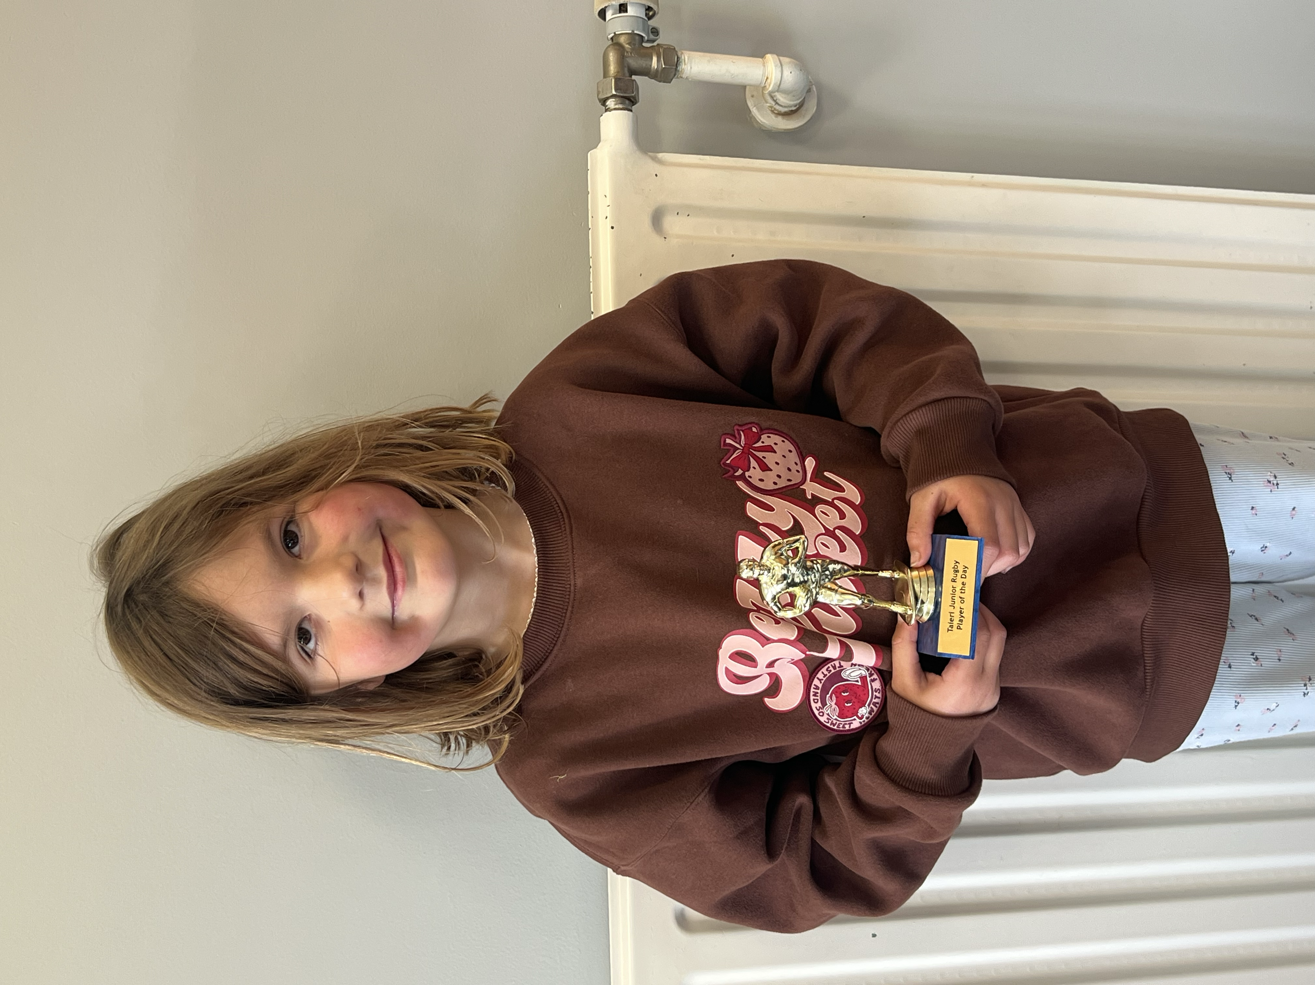

Knowing if your child is well enough to go to school — guidance for parents and caregivers.
If you are not sure if your child is well enough to go to school, the Ministry of Health have a quick guide where you can check your child’s symptoms to make an informed decision.
Google – knowing if your child is well enough to go to school.

Upcoming Events
Assembly – 27th May.
3rd Year Teaching Students on placement – 25th May to 12th June.
King’s Birthday – 1st June – School closed.
Board of Trustees Meething – 9th June – 3.30pm in the staffroom.
Aotearoa New Zealand Histories Trips – Dates to be advised.
Year 6, 7 and 8 Bike Trip – Date to be advised.
Matariki Celebration – 1st July – Brighton Hall.
End of Term – 3rd July.

Listenting Laughing Learning Looking After Others
Some Big Rock students who were ‘caught’ displaying our school values this week were –
Rowan Patterson – Learning – always presenting her work to a high standard.
Braxton Parata-Walters – Looking After Others – always going out of his way to help and displaying exceptional manners.
Lilly Scott – Learning – producing some excellent writing in class.
Brianna Jones – Learning – fantastic work in Minecraft Education.
Reminders
After School Care
Bookings or cancellations for After School Care can be made by texting 021 082 50863 or by emailing asc@bigrock.school.nz.

Office Hours
Monday and Wednesday – 8.45am – 3.15pm
Tuesday, Thursday and Friday – 8.45am – 12.15pm
Kelly is only in the office between these hours.
Please note that if your call goes to the answer phone, leave us a message. Staff may not be able to answer the phone at that time but will check the machine as soon as they can.

Sushi
Sushi is available for lunch every second Wednesday. You can order this by using the Kindo/Ezlunch app.
The dates for sushi lunches for the rest of the term are:
Wednesday: 20th May, 3rd June, 17th June and 1st July

💰 Order & win!
Every Ezlunch order placed between 27 April - 22 May goes in the draw to win 1 of 5 x $50 Kindo credits each week.

Lunch Orders
These can be made at the shop on a Friday or dropped at the school office before 9.00am.

Lost Property
This can be located in the library.

Absences
Thank you for getting your absences and late notifications in before 8.50am on Skool Loop.
It saves us a lot of time if we don’t have to chase these up.

The new Stepped Attendence Responce Regulations from the Ministry of Education and what they mean.
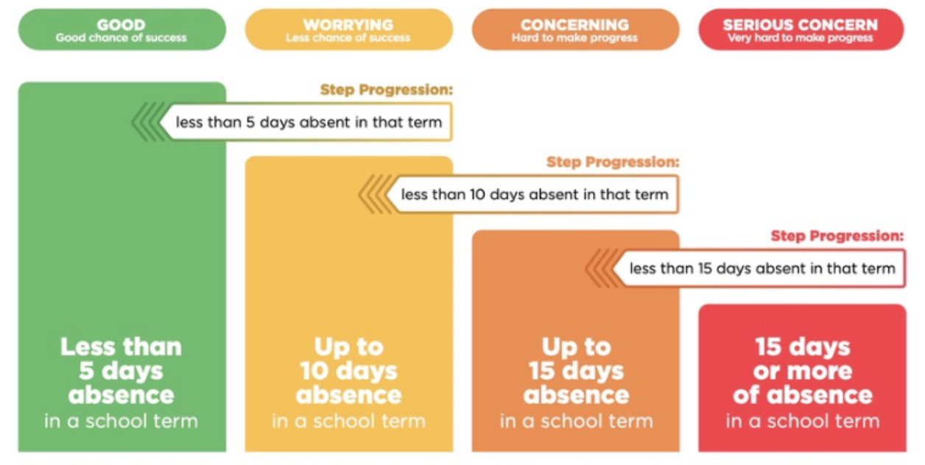
An automatic email will be sent from EDGE, as per Ministry requirements, when absences reach 4.5 half days in a term.

Lisa Lamb
actingprincipal@bigrock.school.nz
Ph 020 432 6657 available between 7.30am and 4.30pm Monday to Friday.

