Good afternoon Big Rock families/whānau.
I am sure you would have heard the news. Big Rock has fairies living in the trees!
Our grounds are looking so good and the students have been so amazing that we have had several fairies take up residence in the trees around the school with more doors appearing each day.
No one has caught sight of any fairies yet, they seem to be quite shy. The children are keeping a sharp eye out for them at break times though.
What’s Been Happening Around the School?
Rooms 3, 4 and 5 had their Aotearoa New Zealand Histories Amazing Race today.
The Yr 6, 7 and 8 students caught the public bus into town with Mr Murray, Mrs Ward, Miss van Aalst and Mr Clark. They met the Yr 4 and 5 students, teachers and parents in the Octagon, had a snack, split into their groups and were off!
Reports back from staff, parents and students is that a lot of fun was had, a lot of learning happened, yummy food was consumed and they were tired.
We also had very positive feedback from the bus drivers, public and the hosts at Law Courts about how polite and well behaved the Big Rock students are.

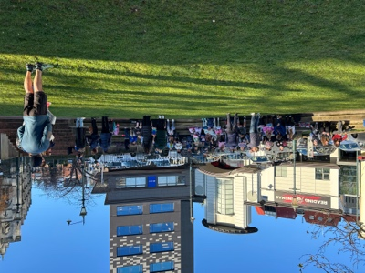 | 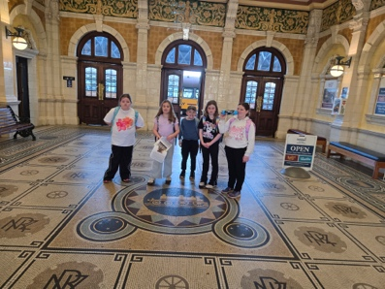 | 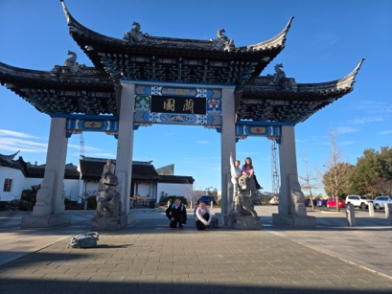 | 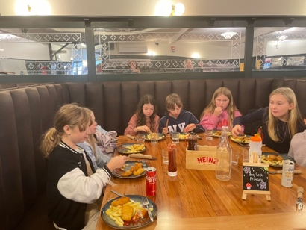
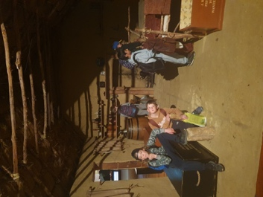 | 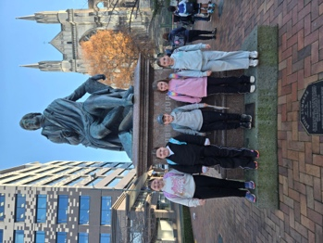 | 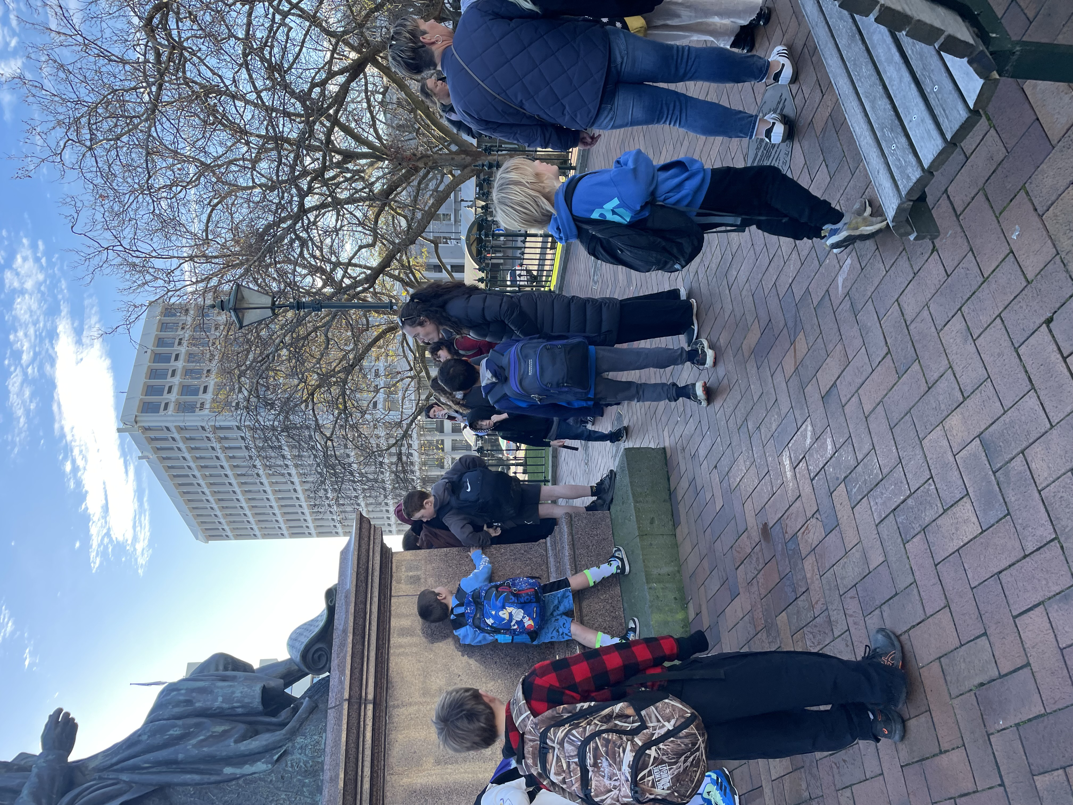 | 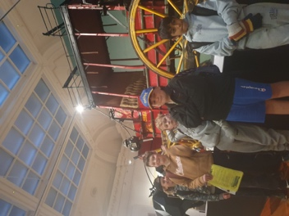

While Rm 3, 4 and 5 were away, Rm 1 and 2 made the most of having the playground to themselves and being able to sit on the seats outside Room 4 to have their snack.
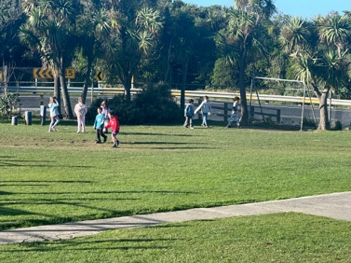 | 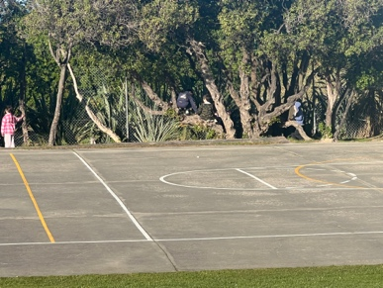 | 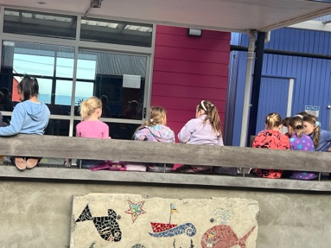
Minecraft Education
One of the many special educational opportunities available at Big Rock is our Minecraft Education Programme lead by Kara. This week the second group of Room 2 students got to design a historic Māori world including a Pā and the Pink and White Terraces. Room 5 students have been amazing during all of the collaborative sessions.
Food for Thought
No homework assignment will ever be more powerful than a parent reading to their child every night. Dr Brad Johnson.
School Sores/Impetigo
Not to jinx it, but we have not seen any new cases in the last 2 weeks.
We do still need you to be vigilant about taking children to the doctor with any unusual spots or crusty, cold sore like lesions. We appreciate your cooperation.

What Time Can Children Be on School Grounds?
At Big Rock School, we understand that some families need to drop their children off before the start of the school day, which is 8.30am. To support these families, the principal is on site and available from 8.00am, and children requiring supervision between 8.00am and 8.30am are welcome.
Children who are not required to be at school early should not arrive before 8.30am.
Teaching staff are not required to be on site until between 8.15am and 8.30am.
Please note: no children are to be on the school grounds before 8.00am.

Listening Laughing Learning Looking After Others
Some Big Rock students who were ‘caught’ displaying our school values this week were –
Pearl Mansfield – outstanding collaborative work in Minecraft.
Brianna Jones - outstanding collaborative work in Minecraft.
Alime Tutgun – outstanding collaborative work in Minecraft.
Baily Jenkinson - outstanding collaborative work in Minecraft.
Sports Roundup

Player of the Day for the Big Rock Hoopsters was Korbyn Parata – Walters. Korbyn also received Best Tackler, Player of the Day and has scored 13 tries so far this year for the Green Island Panda Bears.  This is amazing! | Stella Brown won the cup for Most Improved Rider at the Pony Club prizegiving on Sunday. Stella has been working hard all year and it paid off.  Awesome work! | Player of the Day for the Green Island Black Bears was Caia Worth.  Well done Caia!
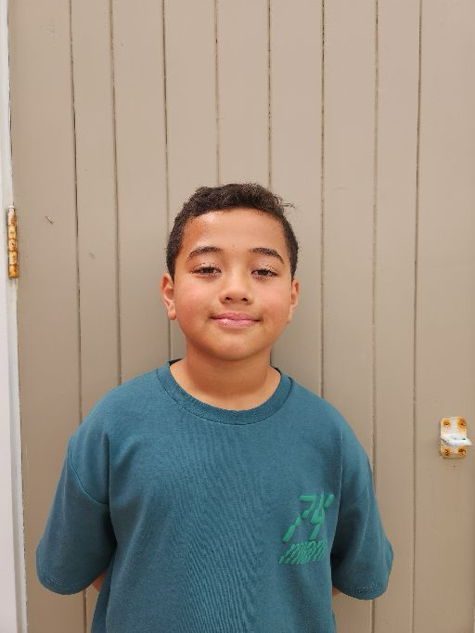 | 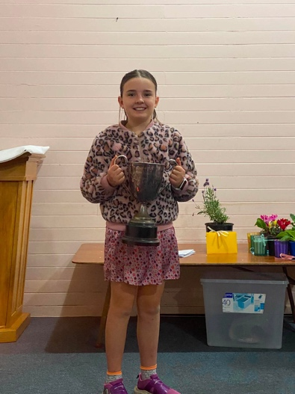 | 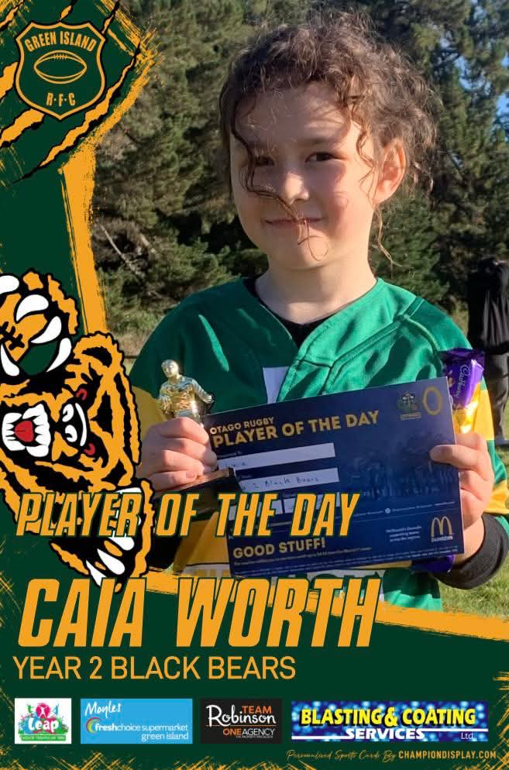

Upcoming Events
Aotearoa New Zealand Histories Trips - Rooms 1 and 2 – Tuesday, June 23rd.
Year 6, 7 and 8 Bike Trip – Date to be advised.
Matariki Celebration – Wednesday, July 1st– Brighton Hall.
End of Term – Friday, July 3rd.
First Day of Term 3 – Monday, July 20th.

Keith from Project Excavation Landscape is responsible for our school looking so smart. If you have any landscaping or excavation projects we highly recommend using his services.



Reminders
Sushi
Sushi is available for lunch every second Wednesday. You can order this by using the Kindo/Ezlunch app.
The dates for sushi lunches for the rest of the term are:
Wednesday: 17th June * Please note there are no orders on the 1st of July as the shop is shut.
School Accounts
Please ensure that your school accounts are up to date. Thank you.
With school camps coming up later in the year, families often opt to start a direct credit now to pre pay for this. If you wish to start a direct credit for camp or to pay your school account, the school bank account details are – Big Rock School – 02 0900 0000225 00
Please let Kelly know if you do start a direct credit payment.
Knowing if your child is well enough to go to school — guidance for parents and caregivers.
If you are not sure if your child is well enough to go to school, the Ministry of Health have a quick guide where you can check your child’s symptoms to make an informed decision.
Google – knowing if your child is well enough to go to school.
After School Care
Bookings or cancellations for After School Care can be made by texting 021 082 50863 or by emailing asc@bigrock.school.nz.
Office Hours
Monday and Wednesday – 8.45am – 3.15pm
Tuesday, Thursday and Friday – 8.45am – 12.15pm
Kelly is only in the office between these hours.
Please note that if your call goes to the answer phone, leave us a message. Staff may not be able to answer the phone at that time but will check the machine as soon as they can.

Lunch Orders
These can be made at the shop on a Friday or dropped at the school office before 9.00am.

Lost Property
This can be located in the library.

Absences
Thank you for getting your absences and late notifications in before 8.50am on Skool Loop.
It saves us a lot of time if we don’t have to chase these up.

The new Stepped Attendence Responce Regulations from the Ministry of Education and what they mean.
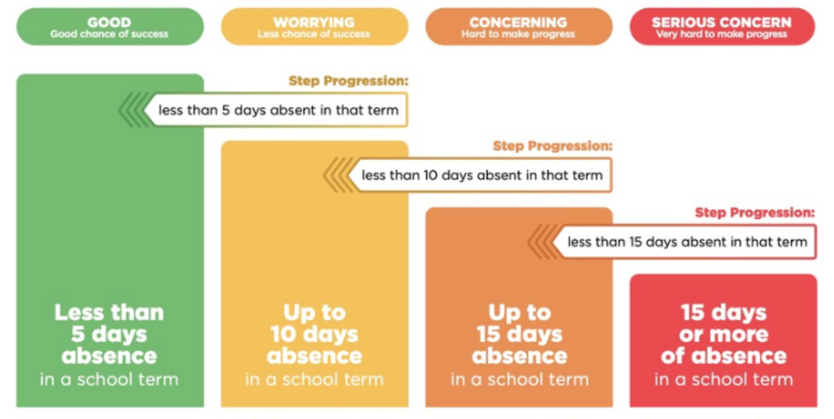
An automatic email will be sent from EDGE, as per Ministry requirements, when absences reach 4.5 half days in a term.
Any absence must be recorded in accordance with the Ministry of Education attendance guidelines.
You can find further information about this on the Big Rock Primary School website under policies.

Lisa Lamb
actingprincipal@bigrock.school.nz

